Procédure GLPI

Ci-dessous vous trouverez les étapes, pour configurer et mettre en place GLPI sur notre réseau :
(Vous aurez besoin d’une machine dédiée, qui servira de serveur)
1. Installation de WAMP.
Il vous faudra d’abord suivre cette première vidéo pour installer WAMP.
Lien de la vidéo :
https://www.youtube.com/watch?v=SnYRl4Y1UXs
Wamp est le logiciel qui permet de créer un serveur en local sur votre machine.
2. Téléchargement de GLPI.
Téléchargez la dernière version stable de GLPI.

Lien du téléchargement :
https://glpi-project.org/fr/telecharger-glpi/

À noter que les mises à jour entre différentes versions peuvent parfois changer l’affichage, mais le processus reste le même. 

3. Extraire les fichiers.
Vous constaterez dans votre dossier de téléchargements, le fichier compressé de GLPI au format « tgz », il vous faudra alors installer WINRAR, si vous ne l’avez pas encore installé, pour extraire les fichiers.
Lien WINRAR :
https://www.win-rar.com/postdownload.html?&L=10

Après l’avoir extrait :
Copiez le nouveau dossier « glpi ».
Allez dans C:\wamp64.
Renommez le fichier « www » comme vous voulez, par exemple « www_default ».
Créez un nouveau dossier « www »
Collez le dossier « glpi » dedans.

4. Installation de GLPI.
Recherchez sur votre navigateur préféré « localhost », puis :

Cliquez sur « glpi ».
Continuer.
Installer.
Continuer.
Suivez les indications de la vidéo à partir de 7min25s :
https://youtu.be/TOR47AL4GXs?si=Jdc1--pBBCznH4tl&t=445

5. Changement des identifiants.

Il est important de procéder au changement des identifiants, surtout pour le compte super admin, afin qu’aucune personne non autorisée n’y accède.
Pour cela il ne faut pas passer par la base de données, mais directement sur GLPI :
Menu déroulant de gauche.
Administration.
Utilisateurs.
Sélectionnez l’utilisateur concerné et lui appliquez les paramètres que vous souhaitez.

6. Mettre en ligne le serveur.
Nous allons maintenant rendre accessible le serveur sur notre réseau.

Pour cela nous allons accéder aux fichiers « httpd.conf » et « httpd-vhosts.conf » en cliquant sur l’icône verte de Wamp à droite de la barre des tâches, puis « Apache ».
Vous y verrez alors apparaître les deux fichiers comme ci-dessous :
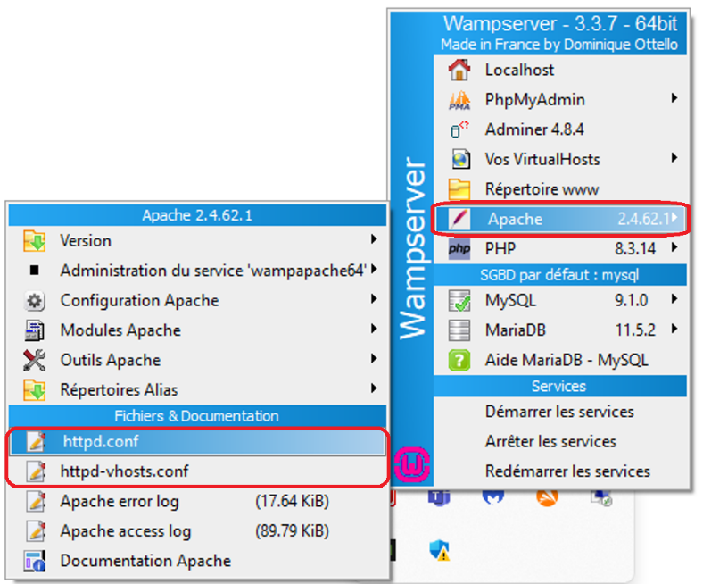

Ensuite, il faut simplement que vous remplaciez chaque « Require local » par « Require all granted » pour laisser le droit d’accès à tout le monde sur le serveur et il sera impossible d’y accéder via localhost à présent.
Il faut également, dans httpd.conf, que le « Listen » soit sur 0.0.0.0 :80
- Voir mon fichier httpd.conf dans la zone de texte pour exemple :
#
# This is the main Apache HTTP server configuration file. It contains the
# configuration directives that give the server its instructions.
# See <URL:http://httpd.apache.org/docs/2.4/> for detailed information.
# In particular, see
# <URL:http://httpd.apache.org/docs/2.4/mod/directives.html>
# for a discussion of each configuration directive.
#
# Do NOT simply read the instructions in here without understanding
# what they do. They're here only as hints or reminders. If you are unsure
# consult the online docs. You have been warned.
#
# Configuration and logfile names: If the filenames you specify for many
# of the server's control files begin with "/" (or "drive:/" for Win32), the
# server will use that explicit path. If the filenames do *not* begin
# with "/", the value of ServerRoot is prepended -- so "logs/access_log"
# with ServerRoot set to "/usr/local/apache2" will be interpreted by the
# server as "/usr/local/apache2/logs/access_log", whereas "/logs/access_log"
# will be interpreted as '/logs/access_log'.
#
# NOTE: Where filenames are specified, you must use forward slashes
# instead of backslashes (e.g., "c:/apache" instead of "c:\apache").
# If a drive letter is omitted, the drive on which httpd.exe is located
# will be used by default. It is recommended that you always supply
# an explicit drive letter in absolute paths to avoid confusion.
ServerSignature On
ServerTokens Full
#
# ServerRoot: The top of the directory tree under which the server's
# configuration, error, and log files are kept.
#
# Do not add a slash at the end of the directory path. If you point
# ServerRoot at a non-local disk, be sure to specify a local disk on the
# Mutex directive, if file-based mutexes are used. If you wish to share the
# same ServerRoot for multiple httpd daemons, you will need to change at
# least PidFile.
#
# Apache variable names used by Apache conf files:
# The names and contents of variables:
# APACHE24, VERSION_APACHE, INSTALL_DIR, APACHE_DIR, SRVROOT
# should never be changed.
Define APACHE24 Apache2.4
Define VERSION_APACHE 2.4.62.1
Define INSTALL_DIR c:/wamp64
Define APACHE_DIR ${INSTALL_DIR}/bin/apache/apache${VERSION_APACHE}
Define SRVROOT ${INSTALL_DIR}/bin/apache/apache${VERSION_APACHE}
ServerRoot "${SRVROOT}"
#
# Mutex: Allows you to set the mutex mechanism and mutex file directory
# for individual mutexes, or change the global defaults
#
# Uncomment and change the directory if mutexes are file-based and the default
# mutex file directory is not on a local disk or is not appropriate for some
# other reason.
#
# Mutex default:logs
#
# Listen: Allows you to bind Apache to specific IP addresses and/or
# ports, instead of the default. See also the <VirtualHost>
# directive.
#
# Change this to Listen on specific IP addresses as shown below to
# prevent Apache from glomming onto all bound IP addresses.
#
Listen 10.0.11.196:80
#
# Dynamic Shared Object (DSO) Support
#
# To be able to use the functionality of a module which was built as a DSO you
# have to place corresponding `LoadModule' lines at this location so the
# directives contained in it are actually available _before_ they are used.
# Statically compiled modules (those listed by `httpd -l') do not need
# to be loaded here.
#
# Example:
# LoadModule foo_module modules/mod_foo.so
#
#LoadModule access_compat_module modules/mod_access_compat.so
LoadModule actions_module modules/mod_actions.so
LoadModule alias_module modules/mod_alias.so
LoadModule allowmethods_module modules/mod_allowmethods.so
LoadModule asis_module modules/mod_asis.so
LoadModule auth_basic_module modules/mod_auth_basic.so
LoadModule auth_digest_module modules/mod_auth_digest.so
#LoadModule auth_form_module modules/mod_auth_form.so
#LoadModule authn_anon_module modules/mod_authn_anon.so
LoadModule authn_core_module modules/mod_authn_core.so
#LoadModule authn_dbd_module modules/mod_authn_dbd.so
#LoadModule authn_dbm_module modules/mod_authn_dbm.so
LoadModule authn_file_module modules/mod_authn_file.so
#LoadModule authn_socache_module modules/mod_authn_socache.so
#LoadModule authnz_fcgi_module modules/mod_authnz_fcgi.so
#LoadModule authnz_ldap_module modules/mod_authnz_ldap.so
LoadModule authz_core_module modules/mod_authz_core.so
#LoadModule authz_dbd_module modules/mod_authz_dbd.so
#LoadModule authz_dbm_module modules/mod_authz_dbm.so
LoadModule authz_groupfile_module modules/mod_authz_groupfile.so
LoadModule authz_host_module modules/mod_authz_host.so
#LoadModule authz_owner_module modules/mod_authz_owner.so
LoadModule authz_user_module modules/mod_authz_user.so
LoadModule autoindex_module modules/mod_autoindex.so
#LoadModule brotli_module modules/mod_brotli.so
#LoadModule buffer_module modules/mod_buffer.so
LoadModule cache_module modules/mod_cache.so
LoadModule cache_disk_module modules/mod_cache_disk.so
#LoadModule cache_socache_module modules/mod_cache_socache.so
#LoadModule cern_meta_module modules/mod_cern_meta.so
LoadModule cgi_module modules/mod_cgi.so
#LoadModule charset_lite_module modules/mod_charset_lite.so
#LoadModule data_module modules/mod_data.so
#LoadModule dav_module modules/mod_dav.so
#LoadModule dav_fs_module modules/mod_dav_fs.so
#LoadModule dav_lock_module modules/mod_dav_lock.so
#LoadModule dbd_module modules/mod_dbd.so
#LoadModule deflate_module modules/mod_deflate.so
LoadModule dir_module modules/mod_dir.so
#LoadModule dumpio_module modules/mod_dumpio.so
LoadModule env_module modules/mod_env.so
#LoadModule evasive_module modules/mod_evasive.so
#LoadModule expires_module modules/mod_expires.so
#LoadModule ext_filter_module modules/mod_ext_filter.so
LoadModule file_cache_module modules/mod_file_cache.so
#LoadModule filter_module modules/mod_filter.so
#LoadModule http2_module modules/mod_http2.so
#LoadModule headers_module modules/mod_headers.so
#LoadModule heartbeat_module modules/mod_heartbeat.so
#LoadModule heartmonitor_module modules/mod_heartmonitor.so
#LoadModule ident_module modules/mod_ident.so
#LoadModule imagemap_module modules/mod_imagemap.so
LoadModule include_module modules/mod_include.so
#LoadModule info_module modules/mod_info.so
LoadModule isapi_module modules/mod_isapi.so
#LoadModule lbmethod_bybusyness_module modules/mod_lbmethod_bybusyness.so
#LoadModule lbmethod_byrequests_module modules/mod_lbmethod_byrequests.so
#LoadModule lbmethod_bytraffic_module modules/mod_lbmethod_bytraffic.so
#LoadModule lbmethod_heartbeat_module modules/mod_lbmethod_heartbeat.so
#LoadModule ldap_module modules/mod_ldap.so
#LoadModule logio_module modules/mod_logio.so
LoadModule log_config_module modules/mod_log_config.so
#LoadModule log_debug_module modules/mod_log_debug.so
#LoadModule log_forensic_module modules/mod_log_forensic.so
#LoadModule lua_module modules/mod_lua.so
#LoadModule macro_module modules/mod_macro.so
#LoadModule md_module modules/mod_md.so
LoadModule mime_module modules/mod_mime.so
#LoadModule mime_magic_module modules/mod_mime_magic.so
LoadModule negotiation_module modules/mod_negotiation.so
#LoadModule proxy_module modules/mod_proxy.so
#LoadModule proxy_ajp_module modules/mod_proxy_ajp.so
#LoadModule proxy_balancer_module modules/mod_proxy_balancer.so
#LoadModule proxy_connect_module modules/mod_proxy_connect.so
#LoadModule proxy_express_module modules/mod_proxy_express.so
#LoadModule proxy_fcgi_module modules/mod_proxy_fcgi.so
#LoadModule proxy_ftp_module modules/mod_proxy_ftp.so
#LoadModule proxy_hcheck_module modules/mod_proxy_hcheck.so
#LoadModule proxy_html_module modules/mod_proxy_html.so
#LoadModule proxy_http_module modules/mod_proxy_http.so
#LoadModule proxy_http2_module modules/mod_proxy_http2.so
#LoadModule proxy_scgi_module modules/mod_proxy_scgi.so
#LoadModule proxy_uwsgi_module modules/mod_proxy_uwsgi.so
#LoadModule proxy_wstunnel_module modules/mod_proxy_wstunnel.so
#LoadModule ratelimit_module modules/mod_ratelimit.so
#LoadModule reflector_module modules/mod_reflector.so
#LoadModule remoteip_module modules/mod_remoteip.so
#LoadModule request_module modules/mod_request.so
#LoadModule reqtimeout_module modules/mod_reqtimeout.so
LoadModule rewrite_module modules/mod_rewrite.so
#LoadModule security2_module modules/mod_security2.so
#LoadModule sed_module modules/mod_sed.so
#LoadModule session_module modules/mod_session.so
#LoadModule session_cookie_module modules/mod_session_cookie.so
#LoadModule session_crypto_module modules/mod_session_crypto.so
#LoadModule session_dbd_module modules/mod_session_dbd.so
LoadModule setenvif_module modules/mod_setenvif.so
#LoadModule slotmem_plain_module modules/mod_slotmem_plain.so
#LoadModule slotmem_shm_module modules/mod_slotmem_shm.so
#LoadModule socache_dbm_module modules/mod_socache_dbm.so
#LoadModule socache_memcache_module modules/mod_socache_memcache.so
#LoadModule socache_redis_module modules/mod_socache_redis.so
#LoadModule socache_shmcb_module modules/mod_socache_shmcb.so
#LoadModule speling_module modules/mod_speling.so
#LoadModule ssl_module modules/mod_ssl.so
#LoadModule status_module modules/mod_status.so
#LoadModule substitute_module modules/mod_substitute.so
#LoadModule unique_id_module modules/mod_unique_id.so
LoadModule userdir_module modules/mod_userdir.so
#LoadModule usertrack_module modules/mod_usertrack.so
#LoadModule version_module modules/mod_version.so
LoadModule vhost_alias_module modules/mod_vhost_alias.so
#LoadModule watchdog_module modules/mod_watchdog.so
#LoadModule xml2enc_module modules/mod_xml2enc.so
PHPIniDir "${APACHE_DIR}/bin"
LoadModule php_module "${INSTALL_DIR}/bin/php/php8.3.14/php8apache2_4.dll"
LoadModule fcgid_module modules/mod_fcgid.so
<IfModule fcgid_module>
FcgidMaxProcessesPerClass 300
FcgidConnectTimeout 10
FcgidProcessLifeTime 0
FcgidMaxRequestsPerProcess 0
FcgidMinProcessesPerClass 0
FcgidFixPathinfo 0
FcgidZombieScanInterval 20
FcgidMaxRequestLen 536870912
FcgidIOTimeout 120
FcgidTimeScore 3
FcgidPassHeader Authorization
Define PHPROOT ${INSTALL_DIR}/bin/php/php
</IfModule>
<IfModule unixd_module>
#
# If you wish httpd to run as a different user or group, you must run
# httpd as root initially and it will switch.
#
# User/Group: The name (or #number) of the user/group to run httpd as.
# It is usually good practice to create a dedicated user and group for
# running httpd, as with most system services.
#
User daemon
Group daemon
</IfModule>
# 'Main' server configuration
#
# The directives in this section set up the values used by the 'main'
# server, which responds to any requests that aren't handled by a
# <VirtualHost> definition. These values also provide defaults for
# any <VirtualHost> containers you may define later in the file.
#
# All of these directives may appear inside <VirtualHost> containers,
# in which case these default settings will be overridden for the
# virtual host being defined.
#
#
# ServerAdmin: Your address, where problems with the server should be
# e-mailed. This address appears on some server-generated pages, such
# as error documents. e.g. admin@your-domain.com
#
ServerAdmin wampserver@wampserver.invalid
#
# ServerName gives the name and port that the server uses to identify itself.
# This can often be determined automatically, but we recommend you specify
# it explicitly to prevent problems during startup.
#
# If your host doesn't have a registered DNS name, enter its IP address here.
#
ServerName 10.0.11.196
#
# Deny access to the entirety of your server's filesystem. You must
# explicitly permit access to web content directories in other
# <Directory> blocks below.
#
<Directory />
AllowOverride none
Require all granted
</Directory>
#
# Note that from this point forward you must specifically allow
# particular features to be enabled - so if something's not working as
# you might expect, make sure that you have specifically enabled it
# below.
#
HostnameLookups Off
#
# DocumentRoot: The directory out of which you will serve your
# documents. By default, all requests are taken from this directory, but
# symbolic links and aliases may be used to point to other locations.
#
DocumentRoot "${INSTALL_DIR}/www"
<Directory "${INSTALL_DIR}/www/">
#
# Possible values for the Options directive are "None", "All",
# or any combination of:
# Indexes Includes FollowSymLinks SymLinksifOwnerMatch ExecCGI MultiViews
#
# Note that "MultiViews" must be named *explicitly* --- "Options All"
# doesn't give it to you.
#
# The Options directive is both complicated and important. Please see
# http://httpd.apache.org/docs/2.4/mod/core.html#options
# for more information.
#
Options +Indexes +FollowSymLinks +Multiviews
#
# AllowOverride controls what directives may be placed in .htaccess files.
# It can be "All", "None", or any combination of the keywords:
# AllowOverride FileInfo AuthConfig Limit
#
AllowOverride all
#
# Controls who can get stuff from this server.
#
# Don't modify this line - Instead modify Require of VirtualHost in httpd-vhost.conf
Require all granted
</Directory>
#
# DirectoryIndex: sets the file that Apache will serve if a directory
# is requested.
#
<IfModule dir_module>
DirectoryIndex index.php index.php3 index.html index.htm
</IfModule>
#
# The following lines prevent .htaccess and .htpasswd files from being
# viewed by Web clients.
#
<Files ".ht*">
Require all granted
</Files>
#
# ErrorLog: The location of the error log file.
# If you do not specify an ErrorLog directive within a <VirtualHost>
# container, error messages relating to that virtual host will be
# logged here. If you *do* define an error logfile for a <VirtualHost>
# container, that host's errors will be logged there and not here.
#
ErrorLog "${INSTALL_DIR}/logs/apache_error.log"
#
# LogLevel: Control the number of messages logged to the error_log.
# Possible values include: debug, info, notice, warn, error, crit,
# alert, emerg.
#
LogLevel warn
<IfModule log_config_module>
#
# The following directives define some format nicknames for use with
# a CustomLog directive (see below).
#
LogFormat "%h %l %u %t \"%r\" %>s %b \"%{Referer}i\" \"%{User-Agent}i\"" combined
LogFormat "%h %l %u %t \"%r\" %>s %b" common
<IfModule logio_module>
# You need to enable mod_logio.c to use %I and %O
LogFormat "%h %l %u %t \"%r\" %>s %b \"%{Referer}i\" \"%{User-Agent}i\" %I %O" combinedio
</IfModule>
#
# The location and format of the access logfile (Common Logfile Format).
# If you do not define any access logfiles within a <VirtualHost>
# container, they will be logged here. Contrariwise, if you *do*
# define per-<VirtualHost> access logfiles, transactions will be
# logged therein and *not* in this file.
#
CustomLog "${INSTALL_DIR}/logs/access.log" common
#
# If you prefer a logfile with access, agent, and referer information
# (Combined Logfile Format) you can use the following directive.
#
#CustomLog "logs/access.log" combined
</IfModule>
<IfModule alias_module>
#
# Redirect: Allows you to tell clients about documents that used to
# exist in your server's namespace, but do not anymore. The client
# will make a new request for the document at its new location.
# Example:
# Redirect permanent /foo http://www.example.com/bar
#
# Alias: Maps web paths into filesystem paths and is used to
# access content that does not live under the DocumentRoot.
# Example:
# Alias /webpath /full/filesystem/path
#
# If you include a trailing / on /webpath then the server will
# require it to be present in the URL. You will also likely
# need to provide a <Directory> section to allow access to
# the filesystem path.
#
# ScriptAlias: This controls which directories contain server scripts.
# ScriptAliases are essentially the same as Aliases, except that
# documents in the target directory are treated as applications and
# run by the server when requested rather than as documents sent to the
# client. The same rules about trailing "/" apply to ScriptAlias
# directives as to Alias.
#
ScriptAlias /cgi-bin/ "${SRVROOT}/cgi-bin/"
</IfModule>
<IfModule cgid_module>
#
# ScriptSock: On threaded servers, designate the path to the UNIX
# socket used to communicate with the CGI daemon of mod_cgid.
#
#Scriptsock cgisock
</IfModule>
#
# "${SRVROOT}/cgi-bin" should be changed to whatever your ScriptAliased
# CGI directory exists, if you have that configured.
#
<Directory "${SRVROOT}/cgi-bin">
AllowOverride None
Options None
Require all granted
</Directory>
<IfModule headers_module>
#
# Avoid passing HTTP_PROXY environment to CGI's on this or any proxied
# backend servers which have lingering "httpoxy" defects.
# 'Proxy' request header is undefined by the IETF, not listed by IANA
#
RequestHeader unset Proxy early
</IfModule>
<IfModule mime_module>
#
# TypesConfig points to the file containing the list of mappings from
# filename extension to MIME-type.
#
TypesConfig conf/mime.types
#
# AddType allows you to add to or override the MIME configuration
# file specified in TypesConfig for specific file types.
#
#AddType application/x-gzip .tgz
#
# AddEncoding allows you to have certain browsers uncompress
# information on the fly. Note: Not all browsers support this.
#
AddEncoding x-compress .Z
AddEncoding x-gzip .gz .tgz
#
# If the AddEncoding directives above are commented-out, then you
# probably should define those extensions to indicate media types:
#
AddType application/x-compress .Z
AddType application/x-gzip .gz .tgz
AddType application/x-httpd-php .php
AddType application/x-httpd-php .php3
#
# AddHandler allows you to map certain file extensions to "handlers":
# actions unrelated to filetype. These can be either built into the server
# or added with the Action directive (see below)
AddHandler application/x-httpd-php .php
#
# To use CGI scripts outside of ScriptAliased directories:
# (You will also need to add "ExecCGI" to the "Options" directive.)
#
#AddHandler cgi-script .cgi
# For type maps (negotiated resources):
#AddHandler type-map var
#
# Filters allow you to process content before it is sent to the client.
#
# To parse .shtml files for server-side includes (SSI):
# (You will also need to add "Includes" to the "Options" directive.)
#
#AddType text/html .shtml
#AddOutputFilter INCLUDES .shtml
</IfModule>
#
# The mod_mime_magic module allows the server to use various hints from the
# contents of the file itself to determine its type. The MIMEMagicFile
# directive tells the module where the hint definitions are located.
#
#MIMEMagicFile conf/magic
#
# Customizable error responses come in three flavors:
# 1) plain text 2) local redirects 3) external redirects
#
# Some examples:
#ErrorDocument 500 "The server made a boo boo."
#ErrorDocument 404 /missing.html
#ErrorDocument 404 "/cgi-bin/missing_handler.pl"
#ErrorDocument 402 http://www.example.com/subscription_info.html
#
#
# MaxRanges: Maximum number of Ranges in a request before
# returning the entire resource, or one of the special
# values 'default', 'none' or 'unlimited'.
# Default setting is to accept 200 Ranges.
#MaxRanges unlimited
#
# EnableMMAP and EnableSendfile: On systems that support it,
# memory-mapping or the sendfile syscall may be used to deliver
# files. This usually improves server performance, but must
# be turned off when serving from networked-mounted
# filesystems or if support for these functions is otherwise
# broken on your system.
# Defaults: EnableMMAP On, EnableSendfile Off
#
EnableMMAP off
EnableSendfile off
# AcceptFilter: On Windows, none uses accept() rather than AcceptEx() and
# will not recycle sockets between connections. This is useful for network
# adapters with broken driver support, as well as some virtual network
# providers such as vpn drivers, or spam, virus or spyware filters.
AcceptFilter http none
AcceptFilter https none
# ThreadStackSize: sets the size of the stack (for autodata)
# of threads which handle client connections and call modules to help process
# those connections. In most cases the operating system default for stack size
# is reasonable, but there are some conditions where it may need to be adjusted.
# Apache httpd may crash when using some third-party modules which use a
# relatively large amount of autodata storage or automatically restart with
# message like: child process 12345 exited with status 3221225725 -- Restarting.
# This type of crash is resolved by setting ThreadStackSize to a value higher
# than the operating system default.
ThreadStackSize 8388608
# Supplemental configuration
#
# The configuration files in the conf/extra/ directory can be
# included to add extra features or to modify the default configuration of
# the server, or you may simply copy their contents here and change as
# necessary.
# Server-pool management (MPM specific)
#Include conf/extra/httpd-mpm.conf
# Multi-language error messages
#Include conf/extra/httpd-multilang-errordoc.conf
# Fancy directory listings
Include conf/extra/httpd-autoindex.conf
# Language settings
#Include conf/extra/httpd-languages.conf
# User home directories
#Include conf/extra/httpd-userdir.conf
# Real-time info on requests and configuration
#Include conf/extra/httpd-info.conf
# Virtual hosts
Include conf/extra/httpd-vhosts.conf
# Local access to the Apache HTTP Server Manual
#Include conf/extra/httpd-manual.conf
# Distributed authoring and versioning (WebDAV)
#Include conf/extra/httpd-dav.conf
# Various default settings
#Include conf/extra/httpd-default.conf
# Configure mod_proxy_html to understand HTML4/XHTML1
<IfModule proxy_html_module>
Include conf/extra/proxy-html.conf
</IfModule>
# Secure (SSL/TLS) connections
#Include conf/extra/httpd-ssl.conf
#
# Note: The following must must be present to support
# starting without SSL on platforms with no /dev/random equivalent
# but a statically compiled-in mod_ssl.
#
<IfModule ssl_module>
SSLRandomSeed startup builtin
SSLRandomSeed connect builtin
</IfModule>
Include "${INSTALL_DIR}/alias/*.conf"

<VirtualHost *:80>
ServerName 10.0.11.196
DocumentRoot "C:/wamp64/www"
<Directory "C:/wamp64/www">
Options Indexes FollowSymLinks MultiViews
AllowOverride All
Require all granted
</Directory>
</VirtualHost>

- Voir mon fichier httpd-vhosts.conf dans la zone de texte pour exemple :

Il vous faut également désactiver complétement le pare-feu, accédez-y via la loupe :

Propriétés du Par-feu Windows Defender .
Pour les trois onglets : Profil de domaine / Profil privé / Profil public.
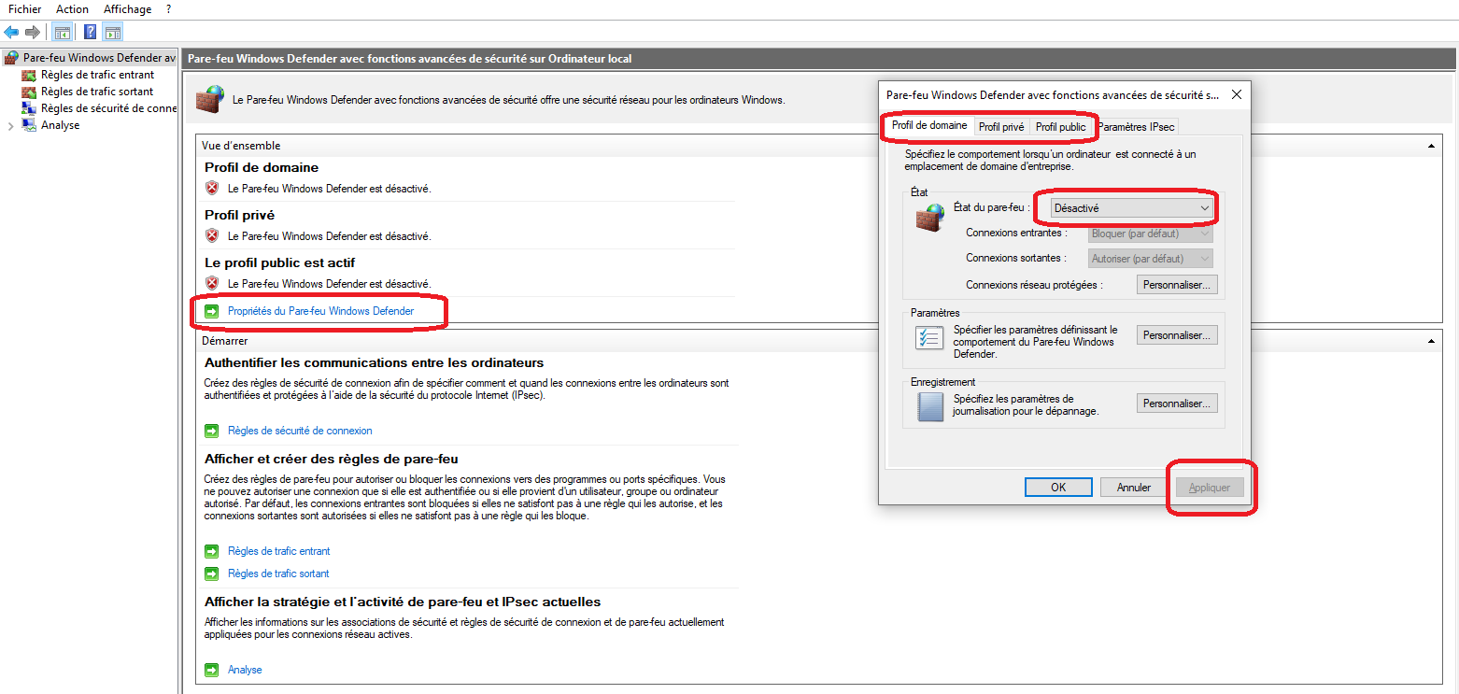
Désactivez l’état du pare-feu.
Appliquer.

7. Choses à savoir.
ATTENTION : Ne pas éteindre la machine, cela coupe le serveur.
En cas d’arrêt il faut simplement exécuter WAMP et renseigner le mot de passe
Administrateur.

- Maintenant, n’importe qui pourra accéder à la page de connexion de GLPI, en recherchant simplement sur le web l’IP de la machine qui héberge le serveur.

- Vous retrouverez l’adresse IP de la machine en faisant la commande « ipconfig » dans l’invité de commandes.
- Vous pouvez également laisser la machine verrouillée, afin que le serveur continue d’être en marche

Si le logo Wamp est :

- Vert, alors tous les services fonctionnent correctement.
- Orange, il y a un problème.
- Rouge, les services ne sont pas opérationnels ou Wamp n’est simplement pas lancé.

Explications simples :
WAMP = serveur
phpMyAdmin = base de données
Apache = permet la configuration de l’accès au serveur
GLPI = logiciel de gestion pour le service informatique
Léo Mahé – Technicien support informatique

